1. In this lecture, we will look at 2 concepts that tie together to provide key advantages to use CLOUD COMPUTING
   1. SCALABILITY
   2. ELASTICITY
2. SCALABILITY
   1. DEFINITION

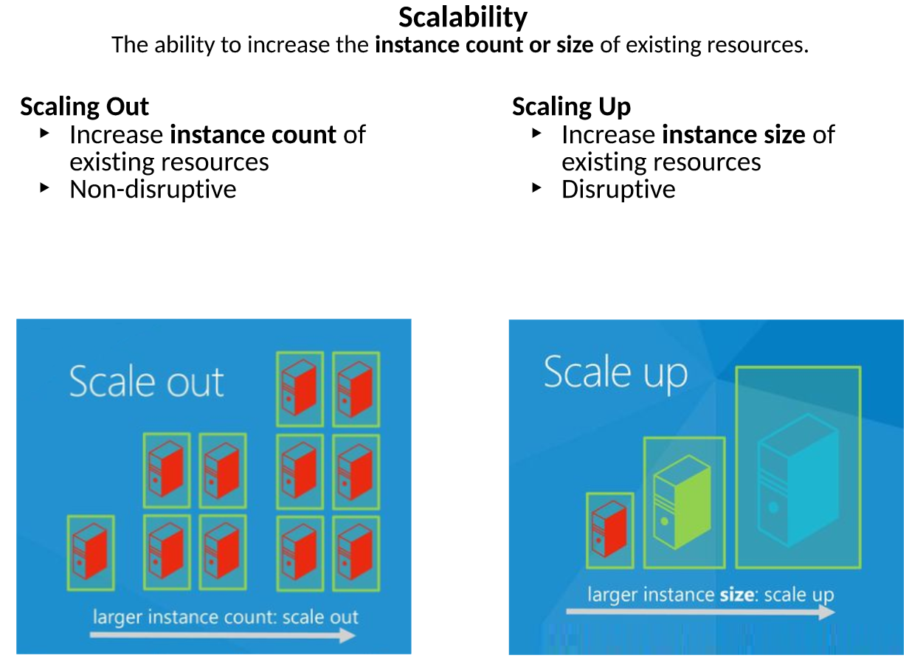

* 1. SCALE OUT – Non Disruptive Change – We don’t have to take any machines off line to SCALE OUT.
  2. There are 2 ways to scale and provides flexibility to increase the resources as you need based on the traffic to your site or workload that our sites are performing.

1. ELASTICITY
   1. Definition



* 1. Building on top of SCALABILITY, we will look at ELASTICITY
  2. ELASTICITY - We can think of entire AZURE CLOUD as RUBBER BAND as you speak.
     1. PULL IT – to make bigger
     2. STOP PULLING - to make it smaller

